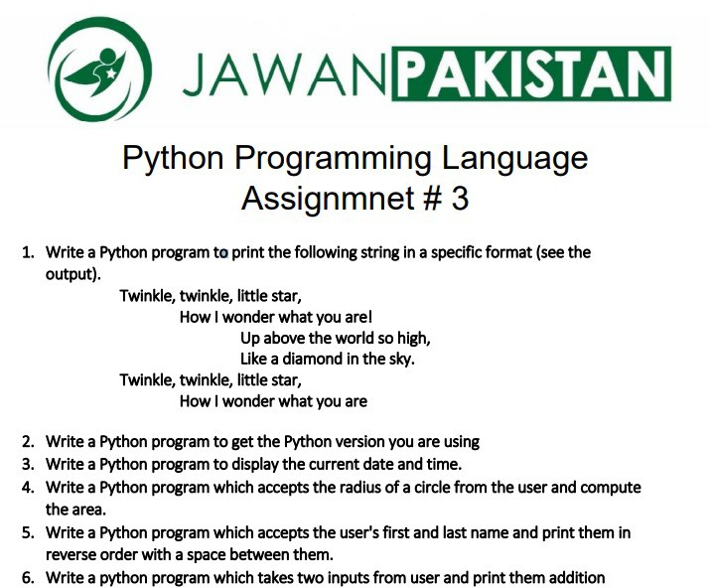

Task 2:

Task 3:

Task 4:

Task 5:

Task 6:

